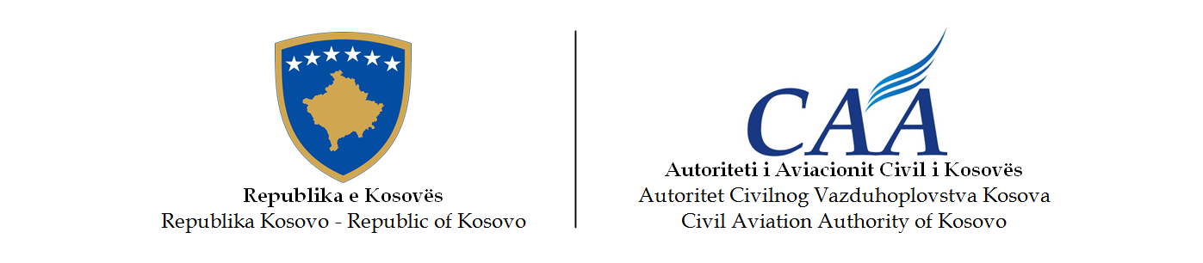

–––––––

Occurrence Reporting
Overview
2024



Autoriteti i Aviacionit Civil i Kosovës - Autoritet Civilnog Vazduhoplovstva Kosova - Civil Aviation Authority of Kosovo
Rr. Zejnel Salihu Street nr. 22 | 10000 Prishtinë | Republika e Kosovës
Tel: +383 (0)38 248 629, +383 (0)38 200 74278 | Web: www.caa-ks.org

Introduction

The Occurrence Reporting System aims to improve aviation safety by ensuring that relevant safety information relating to civil aviation is reported, collected, stored, protected, exchanged, disseminated and analysed. The sole objective of occurrence reporting is the prevention of accidents and incidents and not to attribute blame or liability. The information collected is adequately protected from unauthorised use or disclosure, and it is used strictly for the purpose of maintaining and improving aviation safety.

Occurrence reporting in Kosovo is governed by CAA Regulation No. 09/2017 on the reporting, analysis and follow-up of occurrences in civil aviation, of 6 September 2017, which transposes into the internal legal order of the Republic of Kosovo Regulation (EU) No 376/2014 of the European Parliament and of the Council of 3 April 2014 on the reporting, analysis and follow-up of occurrences in civil aviation. CAA Regulation No. 09/2017 has repealed CAA Regulation 1/2009 on occurrence reporting in civil aviation, CAA Regulation No. 08/2010 laying down implementing rules for the integration into a central repository of information on civil aviation occurrences exchanged in accordance with Directive 2003/42/EC of the European Parliament and of the Council, and CAA Regulation 9/2010 laying down implementing rules for the dissemination to interested parties of information on civil aviation occurrences referred to in Article 7(2) of Directive 2003/42/EC of the European Parliament and of the Council.

Whereas, CAA Regulation No. 11/2017 laying down a list classifying occurrences in civil aviation to be mandatorily reported according to CAA Regulation No. 09/2017, which transposes into the internal legal order of the Republic of Kosovo Commission Implementing Regulation (EU) 2015/1018 of 29 June 2015 laying down a list classifying occurrences in civil aviation to be mandatorily reported according to Regulation (EU) No 376/2014 of the European Parliament and of the Council, sets out the list classifying occurrences to be referred to when reporting, under mandatory reporting systems, occurrences which may represent a significant risk to aviation safety and which fall within the categories of Article 4 (1.) of CAA Regulation No. 09/2017 and the occurrences applicable to aircraft other than complex motor-powered aircraft.

All the aviation occurrences referred to in Article 4 (1.) of CAA Regulation No. 09/2017 and in Annexes I to V to CAA Regulation No. 11/2017 shall be reported to the Civil Aviation Authority of the Republic of Kosovo (the CAA) by the natural persons listed in Article 4 (4.) of CAA Regulation No. 09/2017. This reporting contributes to the improvement of the safety of civil aviation through better understanding of these occurrences to facilitate analysis and trend monitoring so that appropriate and timely preventive action can be taken and aviation safety improved.

The CAA has published on its website (https://caa.rks-gov.net) the Guidance Material on Regulation (EU) No 376/2014 and its practical implementation, which has been provided by the EU Aviation Safety Reporting Portal. This information and guidance material aims to explain the intended purpose of Regulation (EU) No 376/2014 provisions and its implementing regulations, and where relevant, possible means of compliance and examples of good practice, to contribute to a consistent implementation of Regulation 376/2014 and its implementing rules across the EU, which is also being used to contribute to a consistent implementation of CAA Regulation No. 09/2017 and its implementing rules in Kosovo.

The Occurrence Reporting System has been established in Kosovo in 2006. By strict application of rules on confidentiality, protecting the source of safety information and ensuring the confidence of staff working in occurrence reporting systems of civil aviation, the CAA has developed a relationship of trust with the reporters, and subsequently contributed to the improvement of the quality of occurrence reports. Furthermore, the operators have their own Safety Management Systems (SMS), which have advanced significantly in the recent years. The SMS usually integrates a component for treating and addressing reported occurrences, enabling the industry to contribute directly to the collection and analysis of safety-related occurrences.

The CAA is looking forward, in agreement with the European Commission, to update the European Central Repository (EU ECCAIRS Central Database) by transferring to it all information relating to safety stored in the CAA National Database as prescribed in Article 8 (2.) of Regulation No. 09/2017.

The CAA participates in an exchange of information by making all information relating to safety stored in its database available to the competent authorities of other ECAA Partners, EASA and the Commission, in accordance with Article 9 (1.) of CAA Regulation No. 09/2017. Also, in accordance with Article 9 (3.) of CAA Regulation No. 09/2017, the CAA forwards all pertinent safety-related information to the relevant authority of the ECAA Partner or EASA as soon as possible if it identifies safety matters which it considers either to be of interest to other ECAA Partners or EASA, or to possibly require safety action to be taken by other ECAA Partners or EASA.

This Occurrence Reporting Overview contains a description of the occurrence classes and categories, an analysis of the 2024 occurrence reports data and statistics, detailed information on the coded categories of the occurrences reported in 2024, lists with headlines and determined classes of all the occurrences, and a brief description of the most significant occurrences reported in 2024.

Occurrence Classes

The CAA uses the ADREP (Accident/Incident Data Reporting) occurrence class taxonomy to classify occurrences by severity i.e. in terms of safety risk. The ADREP 2000 occurrence class taxonomy is a set of terms used by ICAO and it is part of the ICAO ADREP System.

The ADREP occurrence class taxonomy enables the identification of any rapid action needed when looking at high-risk individual safety occurrences and also enables key risk areas to be identified from aggregated information. This taxonomy helps the relevant entities, and in this case the CAA, in their assessment of occurrences and in determining where best to focus their efforts. It facilitates an integrated and harmonised approach to risk management and thus enables the relevant entities, including the CAA, to focus on safety improvement efforts in a harmonised manner.

Accident

An occurrence associated with the operation of an aircraft which, in the case of a manned aircraft, takes place between the time any person boards the aircraft with the intention of flight until such time as all such persons have disembarked, or in the case of an unmanned aircraft, takes place between the time the aircraft is ready to move with the purpose of flight until such time it comes to rest at the end of the flight and the primary propulsion system is shut down, in which:

- a person is fatally or seriously injured as a result of:
- being in the aircraft, or
- direct contact with any part of the aircraft, including parts which have become detached from the aircraft, or
- direct exposure to jet blast, except when the injuries are from natural causes, self-inflicted or inflicted by other persons, or when the injuries are to stowaways hiding outside the areas normally available to the passengers and crew;

- the aircraft sustains damage or structural failure which:
- adversely affects the structural strength, performance or flight characteristics of the aircraft, and
- would normally require major repair or replacement of the affected component, except for engine failure or damage, when the damage is limited to the engine, its cowlings or accessories; or for damage limited to propellers, wing tips, antennas, tires, brakes, fairings, small dents or puncture holes in the aircraft skin;

- the aircraft is missing or is completely inaccessible.

Serious incident

An incident involving circumstances indicating that an accident nearly occurred.

Note:
- The difference between an accident and a serious incident lies only in the result.
- Examples of serious incidents can be found in Attachment C of ICAO Annex 13 and in the ICAO Accident/Incident Reporting Manual (ICAO Doc 9156).

Incident

An occurrence, other than an accident, associated with the operation of an aircraft which affects or could affect the safety of operation.

Note: The type of incidents which are of main interest to the International Civil Aviation Organization for accident prevention studies are listed in the ICAO Accident/Incident Reporting Manual (ICAO Doc 9156) and ICAO Annex 13.

Occurrence without safety effect (Eurocontrol). A possibly safety related occurrence (not meeting the reporting requirements).

Eurocontrol: An incident which has no safety significance.

Note: This appears to be a contradiction with the ICAO definition of an incident: An occurrence, other than an accident, associated with the operation of an aircraft which affects or could affect the safety of operation.

A possibly safety related occurrence not meeting the reporting requirements. This could be e.g. the result of downgrading the incident after review.

Observation

The observation of a potential safety issue or hazard that, if not rectified could cause or have caused an incident. The date and time of occurrence for an observation is that when it was first observed for the purposes of reporting and not an assessment of how long the safety issue might have been present.

Not determined

The class of the occurrence has not been determined.

Occurrence Categories

The CAA uses the ADREP occurrence category taxonomy to categorize occurrences (i.e. accidents and incidents) and analyse safety trends within these categories. The ADREP 2000 occurrence category taxonomy is a set of terms used by ICAO and it is part of the ICAO Accident/Incident Data Reporting (ADREP) System.

As listed below, each category has a unique name and identifier to permit common coding in accident/incident systems, and a text definition. Each category has also usage notes to clarify the category and aid in coding occurrences, but these notes are not presented here due to space constraints.

ADRM | Aerodrome (Occurrences involving aerodrome design, service, or functionality issues.)
AMAN | Abrupt manoeuvre (The intentional abrupt manoeuvring of the aircraft by the flight crew.)
ARC | Abnormal runway contact (Any landing or take-off involving abnormal runway or landing surface contact.)
ATM | ATM/CNS (Occurrences involving Air traffic management (ATM) or communications, navigation, or surveillance (CNS) service issues.)
BIRD | Birdstrike (Occurrences involving collisions/near collisions with birds.)
CABIN | Cabin safety events (Miscellaneous occurrences in the passenger cabin of transport category aircraft.)
CFIT | Controlled flight into or toward terrain (In-flight collision or near collision with terrain, water, or obstacle without indication of loss of control.)
CTOL | Collision with obstacle(s) during take-off and landing (Collision with obstacle(s), during take-off or landing whilst airborne.)
EVAC | Evacuation (Occurrence where either; (a) person(s) are injured during an evacuation; (b) an unnecessary evacuation was performed; (c) evacuation equipment failed to perform as required; or (d) the evacuation contributed to the severity of the occurrence.)
EXTL | External load related occurrences (Occurrences during or as a result of external load or external cargo operations.)
F-NI | Fire/smoke (non-impact) (Fire or smoke in or on the aircraft, in flight or on the ground, which is not the result of impact.)
F-POST | Fire/smoke (post-impact) (Fire/Smoke resulting from impact.)
FUEL | Fuel related (One or more powerplants experienced reduced or no power output due to fuel exhaustion, fuel starvation/mismanagement, fuel contamination/wrong fuel, or carburettor and/or induction icing.)
GCOL | Ground Collision (Collision while taxiing to or from a runway in use.)
GTOW | Glider towing related events (Premature release, inadvertent release or non-release during towing, entangling with towing, cable, loss of control, or impact into towing aircraft / winch.)
ICE | Icing (Accumulation of snow, ice, freezing rain, or frost on aircraft surfaces that adversely affects aircraft control or performance.)
LA | Laser attack
LALT | Low altitude operations (Collision or near collision with obstacles/objects/terrain while intentionally operating near the surface (excludes take-off or landing phases).)
LOC-G | Loss of control - ground (Loss of aircraft control while the aircraft is on the ground.)
LOC-I | Loss of control - inflight (Loss of aircraft control while or deviation from intended flightpath inflight.)
LOLI | Loss of lifting conditions en-route (Landing en-route due to loss of lifting conditions.)
MAC | Airprox/ ACAS alert/ loss of separation/ (near) midair collisions (Airprox, ACAS alerts, loss of separation as well as near collisions or collisions between aircraft in flight.)
MED | Medical (Medical – occurrences involving illness of persons on board the aircraft.)
NAV | Navigation error (Occurrences involving the incorrect navigation of aircraft on the ground or in the air.)
RAMP | Ground Handling (Occurrences during (or as a result of) ground handling operations.)
RE | Runway excursion (A veer off or overrun off the runway surface.)
RI | Runway incursion - vehicle, aircraft or person (Any occurrence at an aerodrome involving the incorrect presence of an aircraft, vehicle or person on the protected area of a surface designated for the landing and take-off of aircraft.)
SCF-NP | System/component failure or malfunction [non-powerplant] (Failure or malfunction of an aircraft system or component - other than the powerplant.)
SCF-PP | Powerplant failure or malfunction (Failure or malfunction of an aircraft system or component - related to the powerplant.)
SEC | Security related (Criminal/Security acts which result in accidents or incidents (per International Civil Aviation Organization [ICAO] Annex 13).)
TURB | Turbulence encounter (In-flight turbulence encounter.)
UIMC | Unintended flight in IMC (Unintended flight in Instrument Meteorological Conditions (IMC).)
USOS | Undershoot/overshoot (A touchdown off the runway surface.)
WILD | Collision Wildlife (Collision with, risk of collision, or evasive action taken by an aircraft to avoid wildlife on a runway or on a helipad/helideck in use.)
WSTRW | Wind shear or thunderstorm. (Flight into wind shear or thunderstorm.)
OTHR | Other (Any occurrence not covered under another category.)
UNK | Unknown or undetermined (Insufficient information exists to categorize the occurrence.)

An important element of the occurrence category design is that it permits the association of multiple categories with an occurrence. Meaning, for example, if an engine failure occurred, and loss of control followed, the occurrence would be coded in both categories. Multiple coding supports the primary focus of the CAA - accident prevention - in which every pertinent element is investigated, recorded, and analysed.

Statistical Data Analysis

As shown in the Figure below, during the year 2024 the CAA has received reports for a total of 263 occurrences in civil aviation, which is a significant increase compared to previous years.

Figure 1. Number of occurrences reported over the years: 2011- 2024

The number of 263 occurrences reported in 2024 is higher by 70 occurrences or 36% than the average of 193 occurrences of the previous 13 years, 2011 - 2024. Whereas the total number of occurrences reported to the CAA, from 2006 (when the occurrence reporting system was established in Kosovo) to the end of 2024, reached a total of 2710 occurrences.

Figure 2 below displays the number of flights that departed per year from PIA “Adem Jashari”, the only operational airport in Kosovo, over the years: 2000 - 2024. The displayed numbers include scheduled, non-scheduled (charter) and ad-hoc commercial flight departures.

Despite the increased number of departures from Prishtina Airport, the number of occurrences decreased. In comparison to the year 2023, the total number of reports in 2024 has shown a decrease of 22.65%, from 340 to 263.

While Figure 3 shows the number of occurrences that occurred per month during the last five years (2020-2024) and that were received by the CAA. The figure shows that the year 2024 had an average number of 21.9 occurrences per month. The year began with 17 occurrences occurred in January, the same in February and increased by 1 in March. The number increased to 20 in April. In June and July, the number of reports was increased to 48 together and the peak on reports is reached in September, with 37 reports. In October the number dropped to 22, almost the same in November to close the year with December receiving 13 reports.

Figure 2. Number of flight departures over the years: 2000 – 2024

Figure 3. Occurrences that occurred per month during the years: 2021-2024 and that were received by the CAA

A higher number of occurrences during the warmer months of the year, from May to September, can be attributed to the higher number of aircraft movements during those months at PIA, the high season in Kosovo, as well as a higher number of bird strikes during the months of May and September. As usual, traffic was lower during the colder months of the year, especially from February to April, which was reflected in the lower number of occurrences. This pattern was repeated during the last three colder months of the year when traffic was relatively high and the number of occurrences was higher compared to the colder months at the beginning of the year. However, it can be concluded that the overall trend of occurrences is increasing.

The occurrences reported in 2024 have been classified into different classes based on the severity of their effect on the safe operations of aircraft and occupants, and on the ability to provide safe ATM and aerodrome services. These classes, along with the classes of the occurrences reported over the previous four years, are shown in Figure 4 below.

As shown in Figure 4, out of the 263 occurrences received by the CAA during 2024, 41 occurrences (15% of the total number of occurrences) were classified as “Occurrences without safety effect”, 57 occurrences (22% of the total number of occurrences) were classified as “Incidents”, 1 occurrence was classified as “Significant incidents”, 163 occurrences (62% of the total number of occurrences) were classified as “Not determined”.

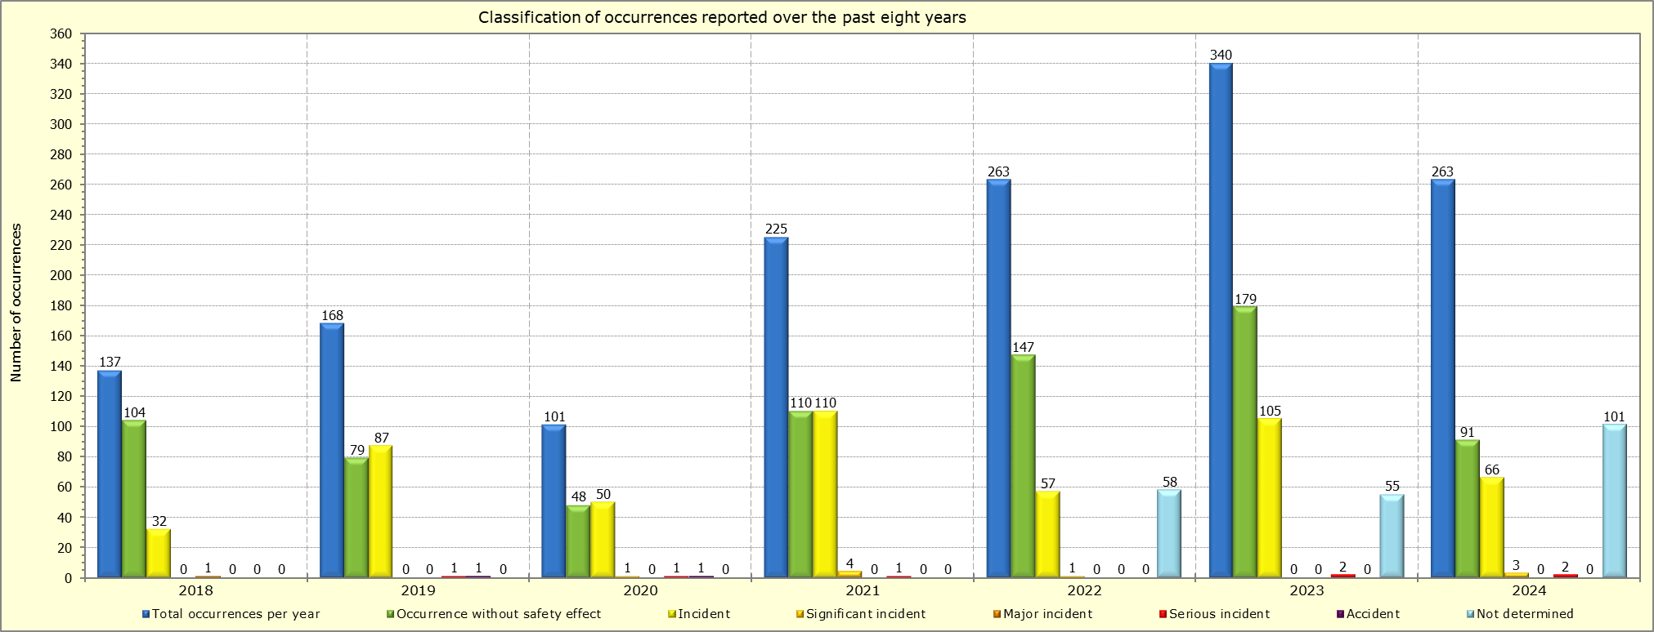

Figure 4. Classification of occurrences reported over the past years: 2018 - 2024

As mentioned above, in addition to being classified, the occurrences reported in 2024 have also been coded into different categories, according to the aviation elements pertinent to these occurrences. These categories, along with the categories of the occurrences reported over the previous three years, are presented in Figure 5 below.

Figure 5. Categorization of occurrences reported over the years 2022, 2023, and 2024

The total number of occurrences reported to CAA, from 2006 to the end of 2024, reached a total of 2710 incidents. There is no significant increase in the number of incident reports compared to the number of flights and this indicates the level of awareness of participants in the aviation industry and their commitment to reporting, and may indicate the satisfactory level of safety in civil aviation.

The reported occurrences are coded into different categories according to the aviation elements involved in these incidents and together with the categories of occurrences of the previous three years are presented in the chart in Figure 5., which is based on the data extracted from the database of CAA.

From the graph in Figure 5., it can be observed that compared to the categories of events of 2022 and 2023, the category of 2024 which has increased is:

- NAV: Navigation error

The categories of occurrences of the year 2023 that have experienced a decrease in comparison to 2023 are:

- RAMP: Ground Handling
- ATM (air traffic management/communication, navigation and surveillance);
- BIRD (bird strike);
- SEC (related to insurance, which contains the subcategory of events related to laser attacks);
- WILD (collision wildlife);
- RI (entering the runway - of the vehicle, aircraft or person);
- ADRM (aerodrome)

Coded Occurrence Categories

This section provides detailed information on the coded categories of the occurrences reported in 2024. It lists the headlines of all the occurrences, along with their determined classes, and provides a brief description of the most significant occurrences reported in 2024.

ADRM: Aerodrome. Occurrences involving aerodrome design, service, or functionality issues. This category includes deficiencies/issues associated with runways, taxiways, ramp area, parking areas, buildings and structures, Crash/Fire/Rescue (CFR) services, obstacles on the Aerodrome property, power supply, lighting, markings, signage, procedures, policies, and standards. Occurrences of this category do not necessarily involve an aircraft.

During 2024, nine (9) occurrences were reported under the ADRM category. Four (4) of these were assigned a secondary category: two (2) as NAV, one (1) as SCF-PP, and one (1) as ATM:

File Number(s) | Headline of Occurrence | Number of Occurrences | Occurrence Class
022, 048, 049 | Miscommunication OCC/TWR Regarding Allocation of Parking Stands | 3 | OWSE / Incident
036, 055, 253, 255, 263 | FOD Found on Runway/Taxiway | 5 | Incident
111 | Distance of Vehicle Disturbing for Crew During Take-Off | 1 | Incident
Five occurrences reported in this category were related to Foreign Object Debris (FOD) at Prishtina International Airport ‘Adem Jashari’. FOD refers to any object found in an inappropriate location at an aerodrome that has the potential to damage equipment or injure personnel. While these events underscored the importance of vigilance in preventing FOD-related hazards, none of them had any impact on flight safety. Prompt action by airport personnel ensured that aircraft, passengers, and staff remained safe at all times. In addition, three occurrences were related to miscommunication between the Operations Control Center (OCC) and the Tower (TWR) during the allocation of parking stands, while one event concerned a perceived disturbance caused by an aerodrome vehicle positioned near the approach area. However, no incursion or operational breach was identified in this case.
BIRD: Birdstrike. Occurrences involving collisions/near collisions with birds. Unconfirmed birdstrikes are also included in this category.

As listed below, during 2024 there were 82 reported birdstrikes, 56 of which were classified as incidents, 25 as occurrences without safety effect and one as serious incident. Starting from 2019 and onwards, every confirmed birdstrike is classified as an incident, except when the results of the investigation suggest otherwise.

File Number(s) | Headline of Occurrence | Number of Occurrences | Occurrence Class
006, 025, 034, 038, 041, 047, 068, 115, 164, 168, 170, 172, 121, 177, 178, 184, 185, 193, 205, 208, 210, 211, 214, 235, 257 | Bird Strike | 25 | Occurrence without safety effect
007, 009, 015, 037, 052, 058, 064, 070, 071, 081, 082, 087, 106, 107, 127, 129, 132, 134, 136, 138, 144, 155, 158, 162, 166, 167, 169, 176, 183, 186, 188, 189, 190, 191, 192, 194, 195, 196, 200, 204, 206, 207, 209, 212, 213, 215, 216, 219, 220, 221, 223, 226, 227, 230, 240, 260 | Bird Strike | 56 | Incident
156 | Bird Strike | 1 | Serious Incident
Note: In two instances, the same occurrence was reported and recorded twice.

Figure 06 below shows the trend of the reported birdstrikes per each month during 2024.

Figure 06. Birdstrikes reported during 2024

Based on the best practice standards produced by the International Bird Strike Committee (IBSC) and those adopted by the International Federation of Air Line Pilots’ Associations (IFALPA), a confirmed or unconfirmed birdstrike occurrence has been standardised as follows:

Confirmed birdstrike: Any reported collision between a bird and an aircraft for which evidence, in the form of a carcass, or other remains, is found on the ground; or damage and/or other evidence is found on the aircraft. Bird remains or complete carcass found on an aerodrome where there is no other obvious cause of death should be treated as a confirmed strike and reported as such accordingly.

Unconfirmed birdstrike: Any reported collision between a bird/wildlife and an aircraft for which no physical evidence is found (i.e. no damage to the aircraft is evident upon inspection, and no bird remains, carcass or blood smears are evident on the airframe).

Of the total birdstrike incidents reported in 2024, 57 were confirmed birdstrikes, indicating the presence of tangible evidence. Twenty of these confirmed events involved only blood marks on the aircraft, with no bird remains or carcasses recovered on the PIA runway. This suggests that these birdstrikes most likely occurred outside the airport’s boundaries.

The reduction in reported birdstrikes compared to 2023 is attributed to the airport operator’s introduction of several new wildlife management measures, including the deployment of additional dispersal equipment, implementation of updated procedures, and the strengthening of continuous wildlife risk management practices. These improvements have collectively contributed to a more effective mitigation of wildlife hazards throughout 2024.

The most frequently involved species in 2024 was the Lapwing (Vanellus). Lapwings are medium-sized, ground-feeding birds typically found in open grasslands, cultivated fields, and areas with soft, moist soil, which support their feeding behavior. Their primary attractants around aerodromes include short grass, insects exposed after rainfall, and open terrain with minimal disturbance. Seasonal flocking behavior, particularly during migration and wintering periods, further increases the likelihood of their presence in the vicinity of the aerodrome, making them a recurring hazard requiring continuous monitoring and management.

WILD: Collision Wildlife. Collision with, risk of collision, or evasive action taken by an aircraft to avoid wildlife on a runway or on a helipad/helideck in use.

This category encompasses encounters with wildlife on any movement area of the aerodrome, including runways, and also accounts for instances where evasive action taken by the flight crew leads to consequences such as gear collapse or collisions off the movement area. Notably, WILD excludes bird strikes, which are separately coded as Bird (BIRD).

As listed below, 7 of the occurrences reported in PIA during 2024 were coded into the WILD category and were classified as incidents.

File Number(s) | Headline of Occurrence | Number of Occurrences | Occurrence Class
112, 236 | Dog Crossing Runway | 2 | Incident
003, 100, 133, 135, 245 | Wildlife Strike (rabbit) | 5 | Incident

The presence of wildlife on the aerodrome and its vicinity poses a serious threat to safe flight operations. In order to manage the wildlife and to minimize the likelihood of collisions between wildlife and aircraft, LKIA has developed a Wildlife Risk Management Program (WRMP), which has been reviewed and approved by the CAA.

To enhance the effectiveness of wildlife management, particularly in response to reported occurrences involving dogs, the aerodrome operator has increased the frequency of on-site inspections, with a focus on identified weak points along the security perimeter fence. In addition, as a last resort to reduce the presence of rabbits within the aerodrome perimeter, the operator has engaged outsourced hunting services.

RAMP: Ground Handling. Occurrences during (or as a result of) ground handling operations, which include collisions that occur while servicing, boarding, loading, and deplaning the aircraft also during boarding and disembarking while helicopter is hovering, injuries to people from propeller/main rotor/tail rotor/fan blade strikes, push-back/power-back/towing events, jet blast and prop/rotor down wash, aircraft external preflight configuration errors that lead to subsequent events, and all parking areas (ramp, gate, tiedowns).

During 2024, a total of 21 occurrences were reported in connection with ground handling operations. Eleven were analysed by aerodrome inspectors and the others by flight safety inspectors. These occurrences highlight the importance of effective mitigation measures to ensure safe and reliable ground handling operations.

File Number(s) | Headline of Occurrence | Number of Occurrences | Occurrence Class
043 | Wrong Pushback Direction | 1 | Occurrence without safety effect
203, 229, 256 | Compartment door issues | 3 | Occurrence without safety effect
217 | Wrong parking stand | 1 | Incident
237, 246, 261 | Damages to the fuselage | 3 | Occurrence without safety effect
238 | Uncommanded Movement of Passenger Stairs | 1 | Incident
239 | Static pillar net holder in compartment not in place | 1 | Occurrence without safety effect
225, 248 | Compartment nets not closed properly | 2 | Occurrence without safety effect
259 | Wrong Aircraft registration in LS & LDM | 1 | Incident
005, 016, 026, 063, 126, 151, 154, 181 | Are being analysed | 8 | Not available

As shown above, 10 occurrences in this category were classified as incidents and one as a “Occurrence without safety effect” and three as “Incident”.

Three occurrences were reported involving dents or scratches to aircraft fuselage doors, all identified during post-arrival visual checks and immediately reported to the pilots; no safety impact was noted, but each case was documented for follow-up and preventive action. Three occurrences were reported involving aircraft compartment door issues during ground handling; all were resolved on-site without damage or safety impact, but were reported to raise awareness and support preventive measures.
In 2024, two occurrences classified as incidents were reported: in the first, an aircraft was initially instructed to park at one stand but taxied to another due to a discrepancy later confirmed by OCC; in the second, a technical issue with passenger stairs at stand led to their removal from service after suspected malfunction, with no safety impact on the aircraft or passengers.

RI: Runway incursion – vehicle, aircraft or person. Any occurrence at an aerodrome involving the incorrect presence of an aircraft, vehicle or person on the protected area of a surface designated for the landing and take-off of aircraft.

File Number(s) | Headline of Occurrence | Number of Occurrences | Occurrence Class
010, 024, 224 | Incorrect presence of a vehicle on the maneuvering area | 3 | Incident
103, 090 | Incorrect presence of a vehicle on the maneuvering area | 2 | Serious Incident

During 2024, five occurrences were reported as runway incursions. Of these, three were classified as incidents and two as serious incidents. Runway incursions represent a significant risk to flight safety, and it is therefore essential that the operator and relevant stakeholders implement effective mitigation measures to minimize the likelihood of recurrence.

SEC: Security related. Criminal/Security acts which result in accidents or incidents (per International Civil Aviation Organization [ICAO] Annex 13. Examples include: a) hijacking and/or aircraft theft; b) interference with a crewmember (e.g., unruly passengers); c) flight control interference; d) ramp/runway/taxiway security; e) sabotage; f) suicide; and g) acts of war.

As listed below, during 2024 there were 16 occurrences related to laser attacks LA (pointing a laser at an aircraft in flight) reported to the CAA, and all of them were classified as incidents. These incidents involved laser attacks on 13 (eleven) civil aircraft and 3 on military operation. The Airport Police was informed about such attacks, and the investigations are ongoing.

Headline of Occurrence | Number of Occurrences | Occurrence Class
Laser Attacks | 16 | Incident

Figure 07 Reported Laser Attacks by Month (2021-2024)

ATM: ATM/CNS. Occurrences involving Air traffic management (ATM) or communications, navigation, or surveillance (CNS) service issues.

The table below and Figure 08 shows that during 2024, occurrences concerning ATM systems and procedures (including Aeronautical Information and Meteorological Services) accounted 34% of all occurrences reported during the year. This percentage does not indicate that safety was compromised, as backup systems are in place for these services. Rather, it reflects the positive reporting culture demonstrated by ANSP personnel.

Occurrences covering ATM technical failures or defects, mainly related to communication, navigation, surveillance, meteorological equipment, aeronautical information systems, etc. are coded under this category, as well as any other occurrence pertaining to or involving ATM procedures and systems. ATM related occurrences are classified according to the effect they have on safety and categorized based on the service/system they affect.

As listed below, 90 occurrences reported during 2024 were coded in the ATM category:

File Number(s) | Headline of Occurrence | Number of Occurrences | Occurrence Class
030, 039, 054, 078, 119, 128, 130, 182, 197 | AFTN Problems | 9 | OWSE
013, 017, 033, 040, 050, 056, 066, 086,  093, 104, 110, 116  122, 141, 148, 149,  152, 153, 165, 173, 179, 199, 244, 252 | Problems with MET Forecasting Systems | 24 | OWSE
011, 012, 231, 254 | Problems with Surveillance Systems | 4 | OWSE
031, 060, 099, 118 | Problems with Radio Communications | 4 | OWSE
032, 065, 067 | Working condition | 3 | OWSE
018, 059, 074, 080, 091, 096, 102, 113,  123, 124, 131, 146,  157, 159, 174, 175,  243 | Problems with Automatic Weather Observing System and its Sensors | 17 | OWSE
044, 109 | Internet failure | 2 | OWSE
020, 069, 072, 083 | Problems with Direct Phone Lines | 4 | OWSE
247 | Navigation system | 1 | OWSE
045, 053, 061, 117 | Aeronautical Information | 4 | OWSE/Significant incident
014, 108, 250 | Radar Data Processing | 3 | OWSE
120, 233 | ATIS Problems | 2 | OWSE
101, 137, 262 | Problems with Surveillance Systems - Gjakova | 3
103 | Runway Incursion | 1 | Serious Incident
023, 234 | Coordination | 2 | OWSE
057, 232 | Power outage | 2 | OWSE
019 | ATC Procedure | 1 | Significant incident
079 | Radar Data Recording | 1 | OWSE
073, 085, 163 | Other | 3 | OWSE

From the table above and the Figure 08, occurrences involving meteorological equipment, communication systems and surveillance systems were the most prominent during 2024, accounting for 46%, 24% and 8%, of the overall ATM occurrences, respectively.

From 46% of occurrences of the meteorological systems, 27% were associated with forecasting system issues, while 19% were linked to the Automatic Weather Observing System (AWOS) and its sensors.

From 24% of occurrences of the communication systems, 5% were related to the radio communication and 19% were related to other communication tools such as AFTN, ATIS, communication lines, internet failure etc.

Out of the total 8% of occurrences related to the surveillance systems, 4.5% were related to the failure of Controller Working Position (CWP), including resets or automatic shutdowns, while 3.5% were related to radar data processing problems.

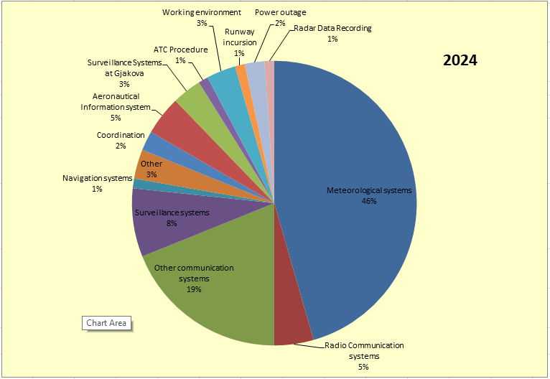

Figure 08. A breakdown of the ATM occurrences into sub-categories

In terms of their effect on safety, around 97% of the ATM related occurrences were classified as occurrences without safety effect (OWSE) and 2% as significant incidents and 1% as serious incident.

Furthermore, the Figure 9 shows graphically sub-categories of the ATM related occurrences according to their severity classification.

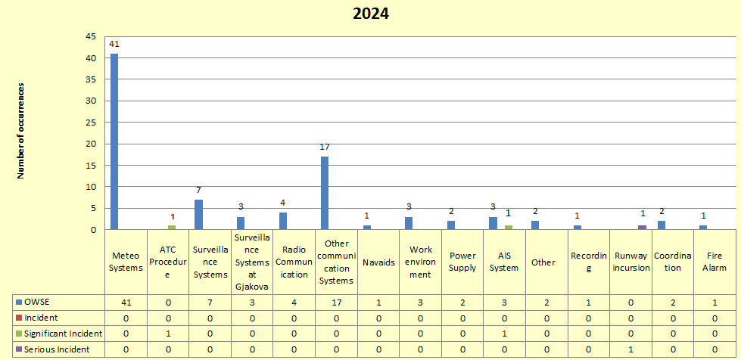

Figure 09. ATM occurrences according to their severity classification

Whereas, Figure 10 below shows the breakdown of the ATM related occurrences, reported during the past two years, into specific sub-categories and the number of occurrences within these sub categories.

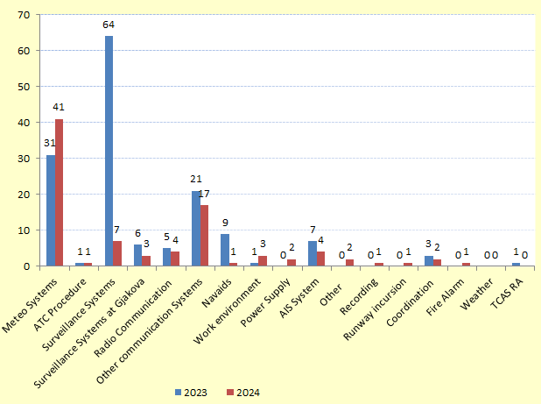
Figure 10. A comparison of the ATM occurrences reported during 2023 and 2024
In comparison between 2023 and 2024, the overall number of occurrences shows a decreasing trend. The most significant reductions are noted in surveillance systems (from 64 in 2023 to 7 in 2024) and Navaid (from 9 to 1), with smaller decreases across several other categories. However, an increase was noted in meteorological systems, which rose from 31 occurrences in 2023 to 41 in 2024.

A summary of the ATM related occurrences according to their sub-categories is provided below.

Radio and other communication systems:

There were 21 reported occurrences which were related to the radio communication systems and all of them were classified as occurrences without safety effect (OWSE). From these, 4 involved radio communication, while another 4 were related to problems with Direct Phone Lines Communications.

As far as other communication systems are concerned, there were 13 reported occurrences, involving mainly Aeronautical Fixed Telecommunication Network (AFTN), internet and ATIS failure. These occurrences were classified as occurrences without safety effect.

There were no occurrences linked directly with the VCSS system.

Meteorological systems:

There were 41 reported occurrences, related to the meteorological observation and forecasting systems, where all of them were classified as occurrences without safety effect.

From the overall occurrences, 17 were related to the Automated Weather Observing System (AWOS) and 24 to the MET Forecasting Systems. It is worth mentioning that for providing meteorological services and products, there are back-up systems that are used to send meteorological products.

During 2024 ANSA has prepared an investigation report for the meteorological forecasting system and an investigation was also conducted regarding the accuracy of the RVR values which is part of the AWOS system.

Surveillance (radar) systems:

There were 7 reported occurrences related to surveillance systems. Of these, 4 involved failures of the Controller Working Position (CWP), including restarts or shutdowns, while 3 were related to radar targets and processing. In the past, an investigation report was prepared, the problems were identified, and all proposed measures were implemented. As a result, a significant decrease in occurrences of this category has been observed.

The reduction in the number of occurrences was also influenced by the intervention of an Italian company contracted for system maintenance, as well as regular maintenance carried out by ANSA. All such occurrences were classified as Occurrences Without Safety Effect (OWSE).
Additionally, 3 occurrences were related to the surveillance system installed in Gjakova, all of which were also classified as OWSE.

Navigation Systems (NAVAID)

There was only one occurrence categorized in the sub-category NAVAID and this occurrence had no effect on safety.

The navigation system at Pristina International Airport has been upgraded from ILS CAT II, in ILS CAT IIIB, enabling aircraft to land in very poor visibility conditions assisted by meteorological system (AWOS).

Other occurrences:

Other reported occurrences were categorized in other sub-categories including problems with work environment, aeronautical information services, runway incursion, ATC procedure, coordination, power outage, data recording system, fire alarm in ANSA premises, problems in AWOS cameras and damage to communication lines with Gjakova Radar.
In total there are 18 occurrences, 15 of them classified as occurrence with no impact on safety, 2 as significant incidents and 1 as serious incident.
The first occurrence classified as incident (significant) is linked with pushback procedure interruption due to conflicting clearances. For this case, an investigation report has been prepared and after the implementation of recommendation this occurrence has been closed.

The second incident (significant) is linked with an occurrence where an arriving flight’s callsign and a departure flight’s exit point were incorrectly recorded on the strip and in Daily Operations Sheet. Since the data were entered manually, the error was human. The managing personnel have discussed the matter with the staff and requested increased attention so that errors of this nature are kept as low as possible.

The serious incident involved a departing aircraft overflying a maintenance vehicle on the runway during take-off, with the crew reporting a serious close call. This was later attributed to misjudgement of clearance. ANSA prepared an investigation report, which was analysed and accepted by the CAA. Immediate measures were also taken by the CAA concerning the ATCO on duty.

Other reported occurrences had no impact on safety.



August 2025

Albulena Gërxhaliu - Emir Hiseni

Laser attacks do not have a specific category as per the ICAO ADREP 2000 Taxonomy, they are included in the SEC (security related) category.
The Ministry of Internal Affairs (MIA) has been designated to handle independently the collection, evaluation, processing, analysis and storage of details of the security related occurrences. However, the CAA remains responsible to handle independently the laser attack occurrences, which are included in the SEC category.

