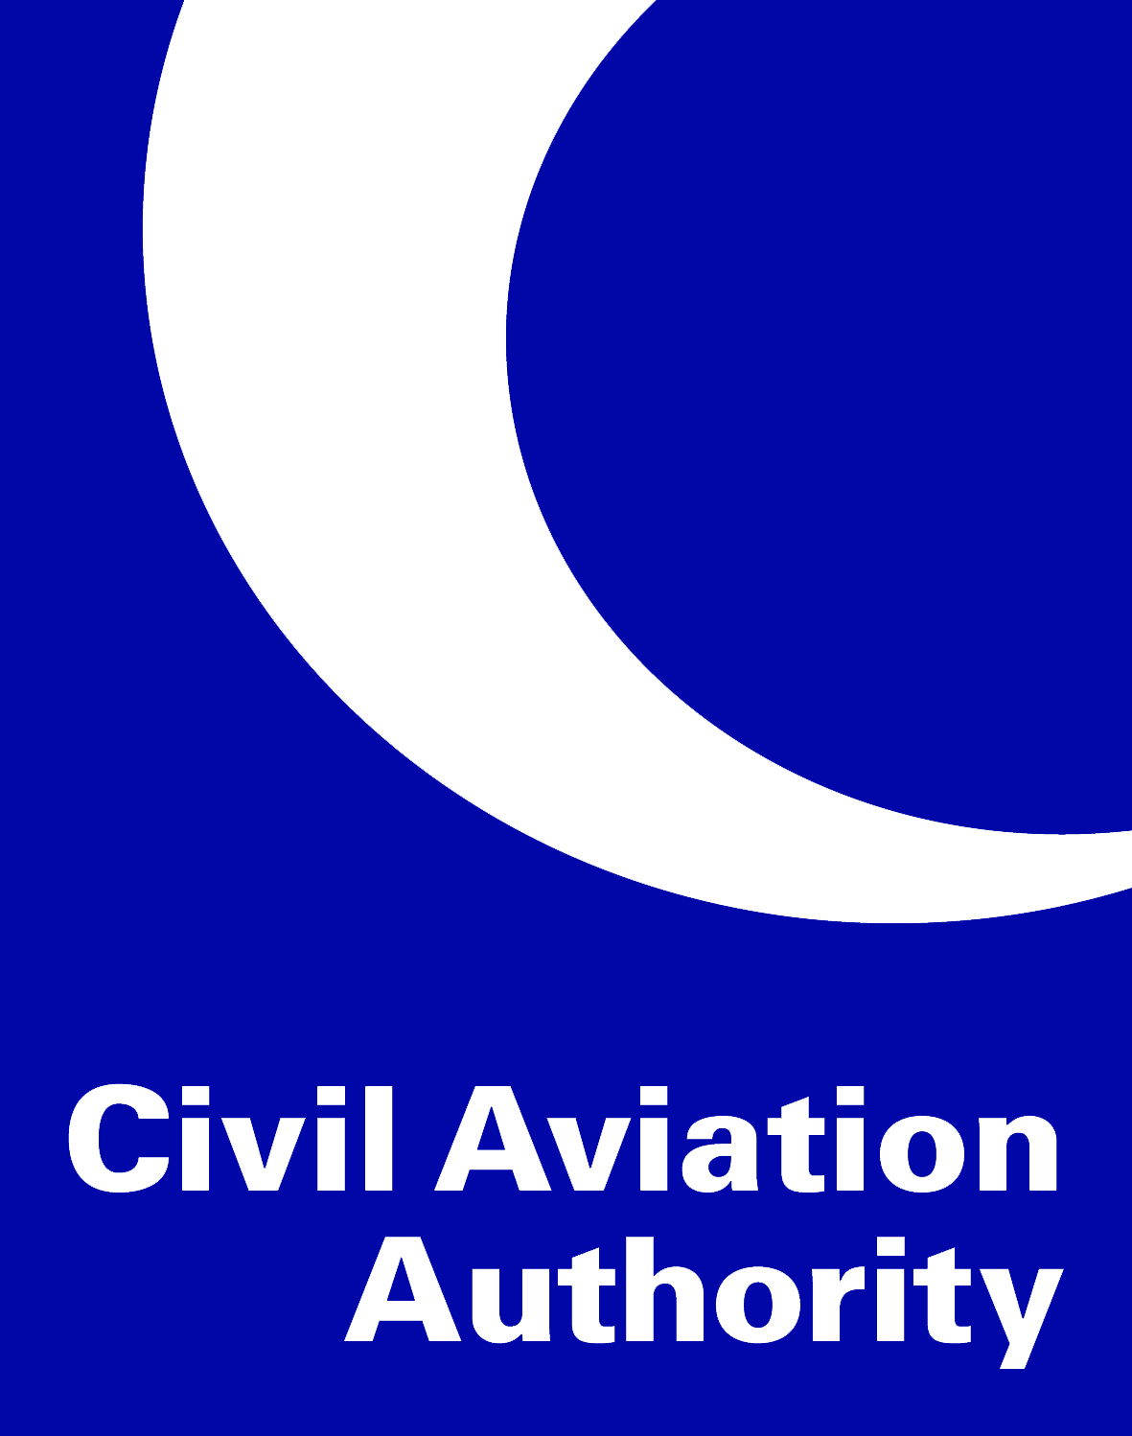

Operations basis (OB)
Checklist
AACK/AGA-FRM 20/Original/21.03.2018

PART 1 – INSTRUCTIONS FOR THE COMPLETION OF THE CERTIFICATION BASIS (CB)

Introduction

This checklist is prepared in accordance with the Regulation No. 17/2017 on Requirements and Administrative Procedures to Aerodromes and the latest Acceptable Means of Compliance (AMC) adopted by the European Aviation Safety Agency (EASA).

Upon receipt of this document from the CAA, the Aerodrome Operator (AO) should complete the document in the manner described below. In completing the OB, you are describing the management, operations and safety processes and procedures you have in place at your aerodrome that allows you to support the management, including safety management, and operation of the aerodrome. Secondly, you are demonstrating where you are meeting the relevant Acceptable Means of Compliance (AMC) and where not, are providing evidence of mitigation measures that may include the proposing of Alternative Means of Compliance (AltMoC).
The OB will support, and reference to, the material contained in the Aerodrome Manual.
Completion of the OB is undertaken in 2 phases.

Phase 1

The completion of this section only requires the reader to understand the scope of the rules. They do not need further work other than reading the rules and understanding their intent.

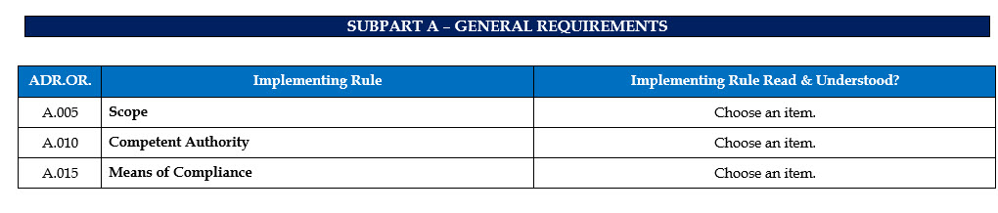

Phase 2
Phase 2 is completed by filling in the individual sections of the OB describing whether you have used the published EASA AMC or are proposing to use an AltMoC to meet the intent of the Implementing Rule (IR). The supporting material for all the questions should be included in the Aerodrome Manual. Therefore, reference to that location is also included in the OB.

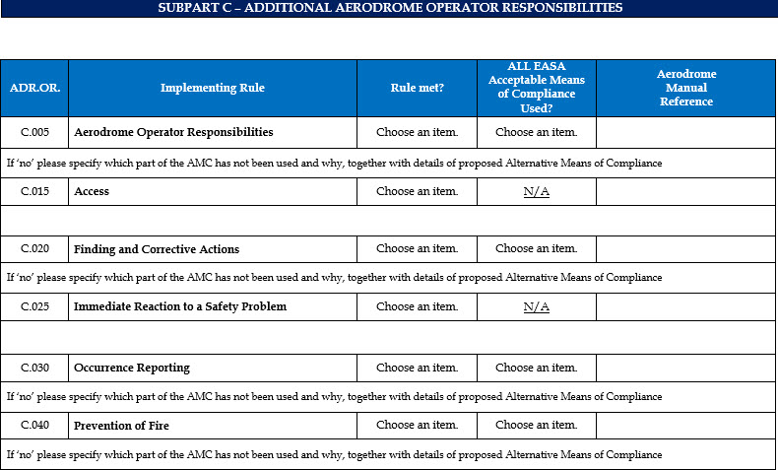

A free text box is added below each rule for additional information you may wish to include in your answer. An example of which may be to propose an alternative means of compliance to the one published.
The completion of this phase finalises the building of the OB and once the document is signed by the Accountable Manager, becomes the legally binding record of the management, including safety management, and operation of the aerodrome.
As described in the rules, the OB must be reviewed when:
  - operations change (e.g. new a/c)
  - the Agency’s regulation changes (i.e. possibly containing new obligation)
  - incidents or accidents occur
  - when change are needed that are subject to the general change management principles of ADR.OR.B.040

PART 2 - OPERATIONS BASIS (CB) CHECKLIST

Aerodrome Name
Aerodrome Operator
Address

Annex III – Organisation Requirements – Aerodrome Operators (Part-ADR.OR)

ANNEX III – SUBPART A – GENERAL REQUIREMENTS

ADR.OR. | Implementing Rule | Implementing Rule Read & Understood?
A.005 | Scope | Choose an item.
A.010 | Competent Authority | Choose an item.
A.015 | Means of Compliance | Choose an item.

SUBPART B – CERTIFICATION

ADR.OR. | Implementing Rule | Implementing Rule Read & Understood?
B.005 | Certification obligations of aerodromes and aerodrome operators | Choose an item.
ADR.OR. | Implementing Rule | Rule met? | ALL EASA Acceptable Means of Compliance Used? | Aerodrome  Manual  Reference
B.015 | Application for a Certificate | N/A | N/A
B.025 | Demonstration of Compliance | Choose an item. | Choose an item.
ADR.OR. | Implementing Rule | Implementing Rule Read & Understood?
B.030 | Terms of the Certificate and privileges of the certificate holder | Choose an item.

ADR.OR. | Implementing Rule | Rule met? | ALL EASA Acceptable Means of Compliance Used? | Aerodrome  Manual  Reference
B.035 | Continued validity of a Certificate | Choose an item. | N/A
B.037 | Continued validity of a declaration of a provider of apron management services | N/A | N/A
B.040 | Changes | Choose an item. | Choose an item.
If ‘no’ please specify which part of the AMC has not been used and why, together with details of proposed Alternative Means of Compliance.

B.050 | Continuing compliance with the Agency’s certification specifications | Choose an item. | N/A
B.060 | Declaration of providers of apron management services | N/A | N/A
B.065 | Termination of operation | Choose an item. | Choose an item.
If ‘no’ please specify which part of the AMC has not been used and why, together with details of proposed Alternative Means of Compliance.

SUBPART C – ADDITIONAL AERODROME OPERATOR RESPONSIBILITIES

ADR.OR. | Implementing Rule | Rule met? | ALL EASA Acceptable Means of Compliance Used? | Aerodrome  Manual  Reference
C.005 | Aerodrome Operator Responsibilities | Choose an item. | Choose an item.
If ‘no’ please specify which part of the AMC has not been used and why, together with details of proposed Alternative Means of Compliance
C.015 | Access | Choose an item. | N/A
C.020 | Finding and Corrective Actions | Choose an item. | Choose an item.
If ‘no’ please specify which part of the AMC has not been used and why, together with details of proposed Alternative Means of Compliance
C.025 | Immediate Reaction to a Safety Problem | Choose an item. | N/A
C.030 | Occurrence Reporting | Choose an item. | Choose an item.
If ‘no’ please specify which part of the AMC has not been used and why, together with details of proposed Alternative Means of Compliance
C.040 | Prevention of Fire | Choose an item. | Choose an item.
If ‘no’ please specify which part of the AMC has not been used and why, together with details of proposed Alternative Means of Compliance
C.045 | Use of alcohol, psychoactive substances and medicines | Choose an item. | N/A
If ‘no’ please specify which part of the AMC has not been used and why, together with details of proposed Alternative Means of Compliance

SUBPART D – MANAGEMENT

ADR.OR. | Implementing Rule | Rule met? | ALL EASA Acceptable Means of Compliance Used? | Aerodrome  Manual  Reference
D.005 | Management system | Choose an item. | Choose an item.
If ‘no’ please specify which part of the AMC has not been used and why, together with details of proposed Alternative Means of Compliance

D.007 | Management of aeronautical data and aeronautical information | Choose an item. | Choose an item.
If ‘no’ please specify which part of the AMC has not been used and why, together with details of proposed Alternative Means of Compliance

D.010 | Contracted activities | Choose an item. | Choose an item.
If ‘no’ please specify which part of the AMC has not been used and why, together with details of proposed Alternative Means of Compliance

D.015 | Personnel requirements | Choose an item. | Choose an item.
If ‘no’ please specify which part of the AMC has not been used and why, together with details of proposed Alternative Means of Compliance

D.017 | Training and proficiency check programmes | Choose an item. | Choose an item.
If ‘no’ please specify which part of the AMC has not been used and why, together with details of proposed Alternative Means of Compliance

D.020 | Facilities requirements | Choose an item. | Choose an item.
If ‘no’ please specify which part of the AMC has not been used and why, together with details of proposed Alternative Means of Compliance
D.025 | Coordination with other organisations | Choose an item. | N/A
If ‘no’ please specify which part of the AMC has not been used and why, together with details of proposed Alternative Means of Compliance
D.027 | Safety programmes | Choose an item. | Choose an item.
If ‘no’ please specify which part of the AMC has not been used and why, together with details of proposed Alternative Means of Compliance

D.030 | Safety reporting system | Choose an item. | Choose an item.
If ‘no’ please specify which part of the AMC has not been used and why, together with details of proposed Alternative Means of Compliance

D.035 | Record keeping | Choose an item. | Choose an item.
If ‘no’ please specify which part of the AMC has not been used and why, together with details of proposed Alternative Means of Compliance

SUBPART E – AERODROME MANUAL AND DOCUMENTATION

ADR.OR. | Implementing Rule | Rule met? | ALL EASA Acceptable Means of Compliance Used? | Aerodrome  Manual  Reference
E.005 | Aerodrome manual | Choose an item. | Choose an item.
If ‘no’ please specify which part of the AMC has not been used and why, together with details of proposed Alternative Means of Compliance

E.010 | Documentation requirements | Choose an item. | N/A

Annex IV – Operations Requirements — Aerodromes (Part-ADR.OPS)

ANNEX IV – SUBPART A – AERODROME DATA

ADR.OPS | Implementing Rule | Rule met? | ALL EASA Acceptable Means of Compliance Used? | Aerodrome  Manual  Reference
A.005 | Aerodrome Data | Choose an item. | Choose an item.
If ‘no’ please specify which part of the AMC has not been used and why, together with details of proposed Alternative Means of Compliance

A.010 | Data quality requirements | Choose an item. | Choose an item.
If ‘no’ please specify which part of the AMC has not been used and why, together with details of proposed Alternative Means of Compliance

A.015 | Coordination between aerodrome operators and providers of aeronautical information services | Choose an item. | Choose an item.
If ‘no’ please specify which part of the AMC has not been used and why, together with details of proposed Alternative Means of Compliance

SUBPART B – AERODROME OPERATIONAL SERVICES, EQUIPMENT AND INSTALLATIONS
ADR.OPS | Implementing Rule | Rule met? | ALL EASA Acceptable Means of Compliance Used? | Aerodrome  Manual  Reference
B.001 | Provision of services | Choose an item. | N/A
B.005 | Aerodrome emergency planning | Choose an item. | Choose an item.
If ‘no’ please specify which part of the AMC has not been used and why, together with details of proposed Alternative Means of Compliance

B.010 | Rescue and firefighting services | Choose an item. | Choose an item.
If ‘no’ please specify which part of the AMC has not been used and why, together with details of proposed Alternative Means of Compliance

B.015 | Monitoring and inspection of movement area and related facilities | Choose an item. | Choose an item.
If ‘no’ please specify which part of the AMC has not been used and why, together with details of proposed Alternative Means of Compliance

B.020 | Wildlife strike hazard reduction | Choose an item. | Choose an item.
If ‘no’ please specify which part of the AMC has not been used and why, together with details of proposed Alternative Means of Compliance

B.025 | Operation vehicles | Choose an item. | Choose an item.
If ‘no’ please specify which part of the AMC has not been used and why, together with details of proposed Alternative Means of Compliance

B.030 | Surface movement guidance and control system | Choose an item. | Choose an item.
If ‘no’ please specify which part of the AMC has not been used and why, together with details of proposed Alternative Means of Compliance

B.035 | Operations in winter conditions | Choose an item. | Choose an item.
If ‘no’ please specify which part of the AMC has not been used and why, together with details of proposed Alternative Means of Compliance

B.040 | Night operations | Choose an item. | Choose an item.
If ‘no’ please specify which part of the AMC has not been used and why, together with details of proposed Alternative Means of Compliance

B.045 | Low visibility operations | Choose an item. | Choose an item.
If ‘no’ please specify which part of the AMC has not been used and why, together with details of proposed Alternative Means of Compliance

B.050 | Operations in adverse weather conditions | Choose an item. | Choose an item.
If ‘no’ please specify which part of the AMC has not been used and why, together with details of proposed Alternative Means of Compliance

B.055 | Fuel quality | Choose an item. | Choose an item.
If ‘no’ please specify which part of the AMC has not been used and why, together with details of proposed Alternative Means of Compliance

B.065 | Visual aids and aerodrome electrical systems | Choose an item. | Choose an item.
If ‘no’ please specify which part of the AMC has not been used and why, together with details of proposed Alternative Means of Compliance
B.070 | Aerodrome works safety | Choose an item. | Choose an item.
If ‘no’ please specify which part of the AMC has not been used and why, together with details of proposed Alternative Means of Compliance

B.075 | Safeguarding of aerodromes | Choose an item. | Choose an item.
If ‘no’ please specify which part of the AMC has not been used and why, together with details of proposed Alternative Means of Compliance

B.080 | Marking and lighting of vehicles and other mobile objects | Choose an item. | Choose an item.
If ‘no’ please specify which part of the AMC has not been used and why, together with details of proposed Alternative Means of Compliance

B.090 | Use of aerodrome by higher code letter aircraft | Choose an item. | Choose an item.
If ‘no’ please specify which part of the AMC has not been used and why, together with details of proposed Alternative Means of Compliance

SUBPART C – AERODROME MAINTENANCE

ADR.OPS | Implementing Rule | Rule met? | ALL EASA Acceptable Means of Compliance Used? | Aerodrome  Manual  Reference
C.005 | General | Choose an item. | Choose an item.
If ‘no’ please specify which part of the AMC has not been used and why, together with details of proposed Alternative Means of Compliance

C.010 | Pavements, other ground surfaces and drainage | Choose an item. | Choose an item.
If ‘no’ please specify which part of the AMC has not been used and why, together with details of proposed Alternative Means of Compliance

C.015 | Visual aids and electrical systems | Choose an item. | Choose an item.
If ‘no’ please specify which part of the AMC has not been used and why, together with details of proposed Alternative Means of Compliance

Aerodrome declaration

I hereby confirm that the details provided within this Operations Basis are correct.

Name and Surname: ______________________________
Date: ______________________________ Signature: ______________________________

For and on behalf of _____________________________________________________________
(Name of Aerodrome and Operator)

CAA use only

Reviewed by: __________________________________________________________________________
Signature: ____________________________________________________________________________

Approved by: ______________________________
Date: ______________________________ Signature: ______________________________

