AACK/AGA-FRM 19/Original/21.03.2018

Certification Basis (CB)
Checklist

Certification Specifications (Version 4) Issued 8th December 2017

PART 1 – INSTRUCTIONS FOR THE COMPLETION OF THE CERTIFICATION BASIS (CB)

Introduction

This checklist is prepared in accordance with the Regulation No. 17/2017 on Requirements and Administrative Procedures to Aerodromes and the latest certification specifications issued by the European Aviation Safety Agency.

Upon receipt of this document from the CAA, the Aerodrome Operator (AO) should complete the documents in the manner described below.

In completing the CB, you are firstly describing the infrastructure and facilities available at your aerodrome that allows you to support the type of operation you are proposing. Secondly, you are demonstrating where you are meeting the relevant Certification Specifications (CS) and where not, are providing evidence of mitigation measures.

Completion of the CB is undertaken in 5 phases.

Phase 1

The completion of this section only requires the reader to understand the scope of the rules. They do not need further work other than reading the rules and understanding their intent.

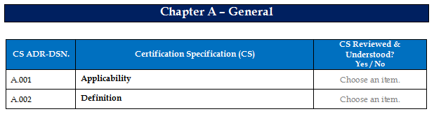

Phase 2

Begin by completing the individual sections of the CB describing the Infrastructure in place at your aerodrome. The sections are divided into Runway, Taxiway, Apron, etc. for ease of identification. The Aerodrome Operator should just describe what they have. Completed example is shown below for Runways.

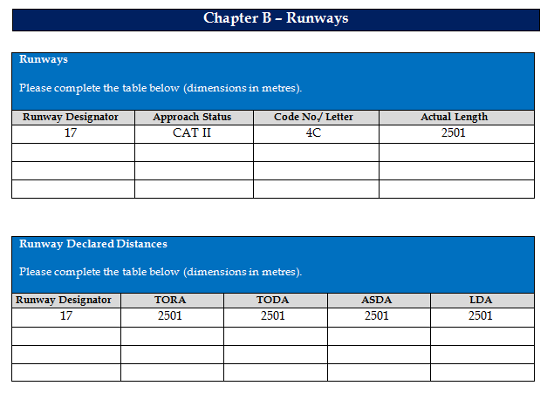

Phase 3

This Phase is where you compare the actual infrastructure and facilities with what is specified in the CS. To do this, you need to refer to the checklist and against each CS indicate whether the relevant CSs applicable to that infrastructure or facility are met, do not meet or are not applicable. You will need to refer to Book 1 Certification Specifications to enable you to complete this phase. Once you have completed this exercise, you will have a checklist that easily identifies where you do not meet the CSs as well as some CSs that have not yet been addressed; these will be addressed in Phase 4. Completed example is shown below for Runways.

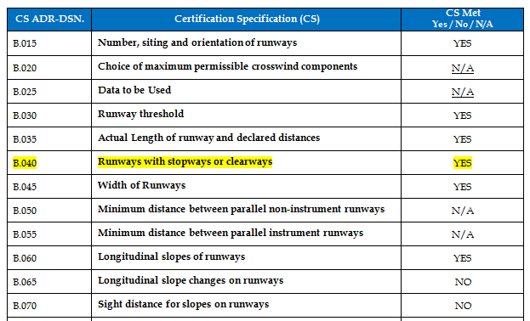

Phase 4

The checklist will easily show where the CS is not met. Attention now reverts back to the description; those parts of the infrastructure or facilities that do not meet the CS need to be identified and mitigation measures developed where appropriate. This is completed on the applicable section of the CB. Completed example is shown below for Runways. (In this example, the mitigation measures are cross referenced to supporting documentation for ease of completion and recording).
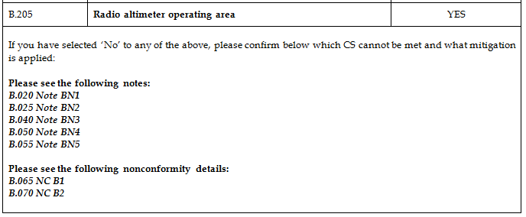

Phase 5

This phase involves finalising the checklist by completing the sections covering the description and recording of any non-compliance as an Equivalent Level of Safety (ELOS) or a Special Condition (SC). The aerodrome operator is invited to propose the location for the Non-compliance for final approval by the CAA or discuss the location with the CAA prior to finalising the CB.

The completion of this phase finalises the building of the CB and once the document is signed by the Accountable Manager, or his representative, becomes the legally binding record of the physical characteristics of the aerodrome. As described in the rules, the CB must be reviewed when:
  - operations change (e.g. new a/c)
  - the infrastructure changes (e.g. new taxiway)
  - the Authority’s CS change (i.e. possibly containing new obligation)
  - incidents or accidents occur
  - when change are needed that are subject to the general change management principles of ADR.OR.B.040

Variations Matrix

 | Variation | Criteria for Option selection
Supported by Safety Assurance Documentation | Equivalent Level of Safety (ELOS) | - Part of the Certification Basis (CB).  - Long term with no known changes planned.  - Can apply to any variation.
 | Special Conditions (SC) | - Part of the CB.  - Can only be issued by Competent Authority (CA).  - Generally issued when the CS is inappropriate or inadequate because:  - the certification specifications cannot be met due to physical, topographical or similar limitations related to the location of the aerodrome;  - the aerodrome has novel or unusual design features; or  - experience from the operation of that aerodrome or other aerodromes having similar design features has shown that safety may be endangered.  - No Known development or change in operation that will affect the variation.  - Costly or disproportionate to make right.
 | Deviation Acceptance and Action Document (DAAD) | - Not part of CB.  - Can apply to any variation.  - Available until 31 December 2024.  - Do not qualify as either of the above.  - Deviation existed prior to 1 January 2018.  - Will need to be reviewed each Audit.  - Known development or change in operation that will affect the variation.

Variations Flowchart

The flowchart is provided to give an overview of where the variation should be placed. The intention is to place most variations in the ELOS or the SC to enable them to be attached to the Certification Basis and thereby need not be subject to regular oversight. However, all variations will be subject to oversight through the change management process.

The variations placed on the DAAD will form part of the Certificate but will be subject to regular oversight.

NO
NO
Is Safety Assurance Documentation Available?

Aerodrome
(Non-compliance)
Can equivalent level of safety be demonstrated?
(Quantified or Qualified?)

Identified future objective to remove the variation?
Is Safety Assurance Documentation Suitable?
ELOS
YES
NO
YES
Is Safety Assurance Documentation Suitable?
Is Safety Assurance Documentation Suitable?
Special Conditions
DAAD

PART 2 - CERTIFICATION BASIS (CB) CHECKLIST

Aerodrome Name
Aerodrome Operator
Address

Chapter A – General

CS ADR-DSN. | Certification Specification (CS) | CS Reviewed & Understood?  Yes / No
A.001 | Applicability | Choose an item.
A.002 | Definition | Choose an item.
CS ADR-DSN. | Certification Specification (CS) | CS Met  Yes / No / N/A
A.005 | Aerodrome Reference Code | Choose an item.
A.010 | [Intentionally Blank] | N/A
If you have selected ‘No’ to any of the above, identifying a non-compliance, please confirm below which CS cannot be met and what mitigation is applied:

Chapter B – Runways

Runways

Please complete the table below (dimensions in metres).

Runway Designator | Approach & Runway Status | Code No./ Letter | Actual Length

Runway Declared Distances

Please complete the table below (dimensions in metres).

Runway Designator | TORA | TODA | ASDA | LDA

CS ADR-DSN. | Certification Specification (CS) | CS Met  Yes / No / N/A
B.015 | Number, siting and orientation of runways | Choose an item.
B.020 | Choice of maximum permissible crosswind components [Intentionally Blank] | N/A
B.025 | Data to be Used [Intentionally Blank] | N/A
B.030 | Runway threshold | Choose an item.
B.035 | Actual Length of runway and declared distances | Choose an item.
B.040 | Runways with stopways or clearways | Choose an item.
B.045 | Width of Runways | Choose an item.
B.050 | Minimum distance between parallel non-instrument runways | Choose an item.
B.055 | Minimum distance between parallel instrument runways | Choose an item.
B.060 | Longitudinal slopes of runways | Choose an item.
B.065 | Longitudinal slope changes on runways | Choose an item.
B.070 | Sight distance for slopes on runways | Choose an item.
B.075 | Distance between slope changes on runways | Choose an item.
B.080 | Transverse slopes on runways | Choose an item.
B.085 | Runway strength | Choose an item.
B.090 | Surface of runways | Choose an item.
B.095 | Runway turn pads | Choose an item.
B.100 | Slopes on runway turn pads | Choose an item.
B.105 | Strength of runway turn pads | Choose an item.
B.110 | Surface of runway turn pads | Choose an item.
B.115 | Width of shoulders for runway turn pads | Choose an item.
B.120 | Strength of shoulders for runway turn pads | Choose an item.
B.125 | Runway shoulders | Choose an item.
B.130 | Slopes on runway shoulders | Choose an item.
B.135 | Width of runway shoulders | Choose an item.
B.140 | Strength of runway shoulders | Choose an item.
B.145 | Surface of runway shoulders | Choose an item.
B.150 | Runway strip to be provided | Choose an item.
B.155 | Length of runway strip | Choose an item.
B.160 | Width of runway strip | Choose an item.
B.165 | Objects on runway strip | Choose an item.
B.170 | Non-precision approach and non-instrument runway strips | Choose an item.
B.175 | Grading of runway strips | Choose an item.
B.180 | Longitudinal slopes on runway strips | Choose an item.
B.185 | Transverse slopes on runway strips | Choose an item.
B.190 | Strength of runway strips | Choose an item.
B.191 | Drainage characteristics of the movement area and adjacent areas | Choose an item.
B.195 | Clearways | Choose an item.
B.200 | Stopways | Choose an item.
B.205 | Radio altimeter operating area | Choose an item.
If you have selected ‘No’ to any of the above, please confirm below which CS cannot be met and what mitigation is applied:

Chapter C – Runway End Safety Areas (RESAs)

Please complete / amend the table below (dimensions in metres)

Runway Designator & Aerodrome Code | Undershoot RESA  Dimensions | Overrun RESA (Landing)  Dimensions | Overrun RESA (Take-off)  Dimensions

CS ADR-DSN. | Certification Specification (CS) | CS Met  Yes / No / N/A
C.210 | Runway End Safety Areas (RESAs) | Choose an item.
C.215 | Dimensions of runway end safety areas | Choose an item.
C.220 | Objects on runway end safety areas | Choose an item.
C.225 | Clearing and grading of runway end safety areas | Choose an item.
C.230 | Slopes on runway end safety areas | Choose an item.
C.235 | Strength of runway end safety areas [Intentionally Blank] | N/A
If you have selected ‘No’ to any of the above, please confirm below which CS cannot be met and what mitigation is applied:

Chapter D – Taxiways

Please complete the table below (dimensions in metres)

Taxiway Designator | Code | Width | Strip Width

CS ADR-DSN. | Certification Specification (CS) | CS Met  Yes / No / N/A
D.240 | Taxiways general | Choose an item.
D.245 | Width of taxiways | Choose an item.
D.250 | Taxiway curves | Choose an item.
D.255 | Junction and intersection of taxiways | Choose an item.
D.260 | Taxiway minimum separation distance | Choose an item.
D.265 | Longitudinal slopes on taxiways | Choose an item.
D.270 | Longitudinal slope changes on taxiways | Choose an item.
D.275 | Sight distance of taxiways | Choose an item.
D.280 | Transverse slopes on taxiways | Choose an item.
D.285 | Strength of taxiways | Choose an item.
D.290 | Surface of taxiways | Choose an item.
D.295 | Rapid exit taxiways | Choose an item.
D.300 | Taxiways on bridges | Choose an item.
D.305 | Taxiway shoulders | Choose an item.
D.310 | Taxiway strip | Choose an item.
D.315 | Width of taxiway strips | Choose an item.
D.320 | Objects on taxiway strips | Choose an item.
D.325 | Grading of taxiway strips | Choose an item.
D.330 | Slopes on taxiway strips | Choose an item.
D.335 | Holding bays, runway-holding positions, intermediate holding positions, and road-holding positions | Choose an item.
D.340 | Location of holding bays, runway-holding positions, intermediate holding positions, and road-holding positions | Choose an item.
If you have selected ‘No’ to any of the above, please confirm below which CS cannot be met and what mitigation is applied:

Chapter E – Aprons

CS ADR-DSN. | Certification Specification (CS) | CS Met  Yes / No / N/A
E.345 | General | Choose an item.
E.350 | Size of Aprons [Intentionally Blank] | N/A
E.355 | Strength of Aprons | Choose an item.
E.360 | Slopes on aprons | Choose an item.
E.365 | Clearance distances on aircraft stands | Choose an item.
If you have selected ‘No’ to any of the above, please confirm below which CS cannot be met and what mitigation is applied:

Chapter F – Isolated aircraft parking position

CS ADR-DSN. | Certification Specification (CS) | CS Met  Yes / No / N/A
F.370 | Isolated aircraft parking position | Choose an item.
If you have selected ‘No’ to any of the above, please confirm below which CS cannot be met and what mitigation is applied:

Chapter G – De-icing / anti-icing facilities

CS ADR-DSN. | Certification Specification (CS) | CS Met  Yes / No / N/A
G.375 | General | Choose an item.
G.380 | Location | Choose an item.
G.385 | Size of de-icing/anti-icing pads | Choose an item.
G.390 | Slopes on de-icing/anti-icing pads | Choose an item.
G.395 | Strength of de-icing/anti-icing pads | Choose an item.
G.400 | Clearance distances on a de-icing/anti-icing pad | Choose an item.
If you have selected ‘No’ to any of the above, please confirm below which CS cannot be met and what mitigation is applied:

Chapter H – Obstacle limitation surfaces

Please confirm the dimension of the Obstacle Limitation Surfaces (OLS) applicable to your aerodrome below (Refer to table J-1 and J-2)

OLS | Dimensions
Outer Horizontal
Conical
Inner Horizontal
Approach
Transitional
Take-off Climb (TOCS)
Obstacle Free Zone (OFZ) | Dimensions
Inner Approach
Inner Transitional
Baulked Landing

CS ADR-DSN. | Certification Specification (CS) | CS Met  Yes / No / N/A
H.405 | Applicability | Choose an item.
H.410 | Outer Horizontal Surface [Intentionally Blank] | N/A
H.415 | Conical Surface | Choose an item.
H.420 | Inner Horizontal Surface | Choose an item.
H.425 | Approach Surface | Choose an item.
H.430 | Transitional Surface | Choose an item.
H.435 | Take-off Climb Surface | Choose an item.
H.440 | Slewed take-off climb surface [Intentionally Blank] | N/A
H.445 | Obstacle Free Zone (OFZ) | Choose an item.
H.450 | Inner approach surface | Choose an item.
H.455 | Inner transitional surface | Choose an item.
H.460 | Balked landing surface | Choose an item.
If you have selected ‘No’ to any of the above, please confirm below which CS cannot be met and what mitigation is applied:

Chapter J – Obstacle limitation requirements

CS ADR-DSN. | Certification Specification (CS) | CS Met  Yes / No / N/A
J.465 | General | Choose an item.
J.470 | Non-instrument runways | Choose an item.
J.475 | Non-precision approach runways | Choose an item.
J.480 | Precision approach runways | Choose an item.
J.485 | Runways meant for take-off | Choose an item.
J.486 | Other objects | Choose an item.
J.487 | Objects outside the obstacle limitation surfaces | Choose an item.
If you have selected ‘No’ to any of the above, please confirm below which CS cannot be met and what mitigation is applied:

Chapter K – Visual aids for navigation (indicators and signalling devices)

CS ADR-DSN. | Certification Specification (CS) | CS Met  Yes / No / N/A
K.490 | Wind direction indicator | Choose an item.
K.495 | Landing direction indicator | Choose an item.
K.500 | Signalling lamp | Choose an item.
K.505 | Signal panels and signal area [Intentionally Blank] | N/A
K.510 | Location of signal panels and signal area [Intentionally Blank] | N/A
K.515 | Characteristics of signal panels and signal area [Intentionally Blank] | N/A
If you have selected ‘No’ to any of the above, please confirm below which CS cannot be met and what mitigation is applied:

Chapter L – Visual aids for navigation (markings)

CS ADR-DSN. | Certification Specification (CS) | CS Met  Yes / No / N/A
L.520 | General – Colour and conspicuity | Choose an item.
L.525 | Runway designation marking | Choose an item.
L.530 | Runway centre line marking | Choose an item.
L.535 | Threshold marking | Choose an item.
L.540 | Aiming point marking | Choose an item.
L.545 | Touchdown zone marking | Choose an item.
L.550 | Runway side stripe marking | Choose an item.
L.555 | Taxiway centre line marking | Choose an item.
L.560 | Interruption of runway markings | Choose an item.
L.565 | Runway turn pad marking | Choose an item.
L.570 | Enhanced taxiway centre line marking | Choose an item.
L.575 | Runway-holding position marking | Choose an item.
L.580 | Intermediate holding position marking | Choose an item.
L.585 | VOR aerodrome checkpoint marking | Choose an item.
L.590 | Aircraft stand marking | Choose an item.
L.595 | Apron safety lines | Choose an item.
L.597 | Apron service road marking | Choose an item.
L.600 | Road-holding position marking | Choose an item.
L.605 | Mandatory instruction marking | Choose an item.
L.610 | Information and marking | Choose an item.
If you have selected ‘No’ to any of the above, please confirm below which CS cannot be met and what mitigation is applied:

Chapter M – Visual aids for navigation (lights)

CS ADR-DSN. | Certification Specification (CS) | CS Met  Yes / No / N/A
M.615 | General | Choose an item.
M.620 | Aeronautical beacons | Choose an item.
M.625 | Approach lighting systems, general and applicability | Choose an item.
M.626 | Simple approach lighting systems | Choose an item.
M.630 | Precision approach category I lighting system | Choose an item.
M.635 | Precision approach category II and III lighting system | Choose an item.
M.640 | Visual approach slope indicator systems | Choose an item.
M.645 | PAPI and APAPI | Choose an item.
M.650 | Approach slope and elevation setting of light units | Choose an item.
M.655 | Obstacle protection surface for PAPI and APAPI | Choose an item.
M.660 | Circling guidance lights | Choose an item.
M.665 | Runway lead-in lighting systems | Choose an item.
M.670 | Runway threshold identification lights | Choose an item.
M.675 | Runway edge lights | Choose an item.
M.680 | Runway threshold and wing bar lights | Choose an item.
M.685 | Runway end lights | Choose an item.
M.690 | Runway centre lights | Choose an item.
M.695 | Runway touchdown zone lights | Choose an item.
M.696 | Simple touchdown zone lights | Choose an item.
M.700 | Rapid exit taxiway indicator lights [Intentionally Blank] | N/A
M.705 | Stopway lights | Choose an item.
M.706 | Runway status lights (RWSL) | Choose an item.
M.710 | Taxiway centre line lights | Choose an item.
M.715 | Taxiway centre line lights on taxiways, runways, rapid exit taxiways, or on other exit taxiways | Choose an item.
M.720 | Taxiway edge lights | Choose an item.
M.725 | Runway turn pad lights | Choose an item.
M.730 | Stop bar lights | Choose an item.
M.735 | Intermediate holding position lights | Choose an item.
M.740 | De-icing/anti-icing facility exit lights | Choose an item.
M.745 | Runway guard lights | Choose an item.
M.750 | Apron floodlighting | Choose an item.
M.755 | Visual docking guidance system | Choose an item.
M.760 | Advanced visual docking guidance system | Choose an item.
M.765 | Aircraft stand manoeuvring guidance lights | Choose an item.
M.770 | Road-holding position light | Choose an item.
M.771 | No-entry bar | Choose an item.
If you have selected ‘No’ to any of the above, please confirm below which CS cannot be met and what mitigation is applied:

Chapter N – Visual aids for navigation (signs)

CS ADR-DSN. | Certification Specification (CS) | CS Met  Yes / No / N/A
N.775 | General | Choose an item.
N.780 | Mandatory instruction signs | Choose an item.
N.785 | Information signs | Choose an item.
N.790 | VOR aerodrome checkpoint sign | Choose an item.
N.795 | Aircraft stand identifications signs | Choose an item.
N.800 | Road-holding position signs | Choose an item.
If you have selected ‘No’ to any of the above, please confirm below which CS cannot be met and what mitigation is applied:

Chapter P – Visual aids for navigation (markers)

CS ADR-DSN. | Certification Specification (CS) | CS Met  Yes / No / N/A
P.805 | General | Choose an item.
P.810 | Unpaved runway edge markers | Choose an item.
P.815 | Stopway edge markers | Choose an item.
P.820 | Edge markers for snow-covered runways | Choose an item.
P.825 | Taxiway edge markers | Choose an item.
P.830 | Taxiway centre line markers | Choose an item.
P.835 | Unpaved taxiway edge markers | Choose an item.
If you have selected ‘No’ to any of the above, please confirm below which CS cannot be met and what mitigation is applied:

Chapter Q – Visual aids for denoting obstacles

CS ADR-DSN. | Certification Specification (CS) | CS Met  Yes / No / N/A
Q.840 | Objects to be marked and/or lighted | Choose an item.
Q.841 | Objects to be marked and/or lighted outside the lateral boundaries of the obstacle limitation surface | Choose an item.
Q.845 | Marking of objects | Choose an item.
Q.846 | Lighting of fixed objects | Choose an item.
Q.847 | Lighting of fixed objects with a height less than 45m above ground level | Choose an item.
Q.848 | Lighting of fixed objects with a height 45m to a height less than 150m above ground level | Choose an item.
Q.849 | Lighting of fixed objects with a height 150m or more above ground level | Choose an item.
Q.850 | Lighting of objects | Choose an item.
Q.851 | Marking and lighting of wind turbines | Choose an item.
Q.852 | Marking and lighting of overhead wires, cables, supporting towers, etc. | Choose an item.
If you have selected ‘No’ to any of the above, please confirm below which CS cannot be met and what mitigation is applied:

Chapter R – Visual aids for denoting restricted use areas

CS ADR-DSN. | Certification Specification (CS) | CS Met  Yes / No / N/A
R.855 | Closed runways and taxiways, or parts thereof | Choose an item.
R.860 | Non-load-bearing surfaces | Choose an item.
R.865 | Pre-threshold area | Choose an item.
R.870 | Unserviceable areas | Choose an item.
If you have selected ‘No’ to any of the above, please confirm below which CS cannot be met and what mitigation is applied:

Chapter S – Electrical systems

CS ADR-DSN. | Certification Specification (CS) | CS Met  Yes / No / N/A
S.875 | Electrical power supply systems for air navigation facilities | Choose an item.
S.880 | Electrical power supply systems for visual aids | Choose an item.
S.885 | System design | Choose an item.
S.890 | Monitoring | Choose an item.
S.895 | Serviceability levels | Choose an item.
If you have selected ‘No’ to any of the above, please confirm below which CS cannot be met and what mitigation is applied:

Chapter T – Aerodrome operational services, equipment and installation

CS ADR-DSN | Certification Specification (CS) | CS Met  Yes / No / N/A
T.900 | Emergency access and service roads | Choose an item.
T.905 | Fire stations | Choose an item.
T.910 | Equipment frangibility requirements | Choose an item.
T.915 | Siting of equipment and installations on operational areas | Choose an item.
T.920 | Fencing | Choose an item.
T.921 | Autonomous runway incursion warning system (ARIWS) | Choose an item.
If you have selected ‘No’ to any of the above, please confirm below which CS cannot be met and what mitigation is applied:

Chapter U – Colours for aeronautical ground lights, markings, signs and panels

CS ADR-DSN | Certification Specification (CS) | CS Met  Yes / No / N/A
U.925 | General | Choose an item.
U.930 | Colours for aeronautical ground lights | Choose an item.
U.935 | Colours for markings, signs and panels | Choose an item.
U.940 | Aeronautical ground light characteristics | Choose an item.
If you have selected ‘No’ to any of the above, please confirm below which CS cannot be met and what mitigation is applied:

Equivalent Level of Safety (ELOS)

Date | Relevant Certification Specification (CS) | Description Of ELOS | Reference to supporting documentation

Special Conditions (SC)

Date | Relevant Certification Specification (CS) | Description Of SC | Reference to supporting documentation

Aerodrome declaration

I hereby confirm that the details provided within this Certification Basis are correct.

Name and Surname: ______________________________
Date: ______________________________ Signature: ______________________________

For and on behalf of _____________________________________________________________
(Name of Aerodrome and Operator)

CAA use only

Reviewed by: __________________________________________________________________________
Signature: ____________________________________________________________________________

Approved by: ______________________________
Date: ______________________________ Signature: ______________________________

